**NEWTON'S LAW OF COOLING**

**A PROJECT REPORT**

**Submitted by**

**Shivakumar Rs - 1RVU23CSE429**

**Shivanandreddy - 1RVU23CSE431  
Sharanappa -1RVU23CSE419**

*as part of the* ***Continuous Internal Evaluation***

*for the course*

**CS1802 Calculus and Laplace Transforms**

*Offered in*

## Semester IV

*of*

**B.Tech**

**(**

**Hons**

**)**



**School of Computer Science and Engineering RV University RV Vidyaniketan,8th Mile, Mysuru Road, Bengaluru, Karnataka, India - 562112**

**APRIL & 2025**

## DECLARATION

I, **Shivakumar Rs(**1RVU23CSE429), **Shivanandreddy**(1RVU23CSE431)**, Sharanappa** (1RVU23CSE419) students **fourth** semester B.Tech in **Computer Science & Engineering,** at School of Computer Science and Engineering, **RV University,** hereby declare that the project work titled “**Newton's law of cooling**” has been carried out by us and submitted in partial fulfilment for the award of degree in **Bachelor of Technology in Computer Science & Engineering** during the academic year **2023-2024**. Further, the matter presented in the project has not been submitted previously by anybody for the award of any degree or any diploma to any other University, to the best of our knowledge and faith.

| **Name** | **USN** | **Signature** |
| --- | --- | --- |
| Shivakumar R S | 1RVU23CSE429 |  |
| Shivanandreddy | 1RVU23CSE431 |  |
| Sharanappa | 1RVU23CSE419 |  |

Place: Pattanagere, Bengaluru

Date: 15-04-2025



## School of Computer Science and Engineering

RV University

RV Vidyaniketan,8th Mile, Mysuru Road, Bengaluru, Karnataka, India – 562112

## CERTIFICATE

This is to certify that the project work titled **“Newton's law of cooling**” is performed by

**Shivakumar Rs(**1RVU23CSE429), **Shivanandreddy**(1RVU23CSE431)**, Sharanappa** (1RVU23CSE419) a bonafide students of Bachelor of Technology at the School of Computer Science and Engineering, RV university, Bangaluru as part of the **CIE-3 component** for the course **CS 1802** **Calculus and Laplace Transforms** offered in Semester IV of Bachelor of Technology in Computer Science & Engineering, during the Academic year **2024-2025**.

Name of Course Faculty: Amruthesh Bhat

Signature with date of Faculty

**TABLE OF CONTENTS**

|  |  |  |
| --- | --- | --- |
|  | **TITLE** |  |
|  |  |  |
| **1.0** | **INTRODUCTION** | **1** |
|  | 1.1 Objectives | 2 |
| **2.0** | **THE MODEL** | **3** |
|  | 2.1 Phenomenal Description | 3 |
|  | 2.2 Variables and Parameters | 4 |
| **3.0** | **METHOD OF SOLUTIONS** | **5** |
|  | 3.1 Laplace Transform | 5 |
|  | 3.2 Inverse Laplace Transform | 5 |
| **4.0** | **RESULT AND DISCUSSION** | **6** |
|  | 4.1 Qualitative Analysis | 6 |
|  | 4.2 Graphical Representation | 7 |
| **5.0** | **CONCLUSION** | **8** |
| **6.0** | **REFERNCE** | **9** |

1. **INTRODUCTION**

**Newton’s Law of Cooling** describes the rate at which the temperature of an object changes when it is exposed to a surrounding medium of different temperature. This law, developed by Sir Isaac Newton, is based on the principle that the rate of heat loss of a body is directly proportional to the difference between the body’s temperature and the ambient temperature, assuming the surrounding temperature remains constant.

This law is widely used in various scientific and engineering fields due to its simplicity and practical applicability. The mathematical formulation involves a first-order linear differential equation, which can be effectively solved using **Laplace Transforms**, a powerful tool for analyzing linear time-invariant systems.

**1.1 Objectives**

The primary objectives of this project are:

* To understand and model **Newton’s Law of Cooling** using differential equations.
* To apply **Laplace Transform techniques** for solving the governing equation.
* To analyze the cooling behavior of an object placed in a constant temperature environment.
* To interpret the mathematical solution in terms of physical behavior over time.
* To explore **real-world applications** of the model in areas such as forensic science, food safety, and thermal system design.

**2.0 THE MODEL**

**2.1 Phenomenal Description**

Newton’s Law of Cooling describes how the temperature of a hot object decreases over time when placed in a surrounding medium that is cooler. The key idea behind this law is that the rate at which an object loses heat is directly proportional to the difference between the temperature of the object and the temperature of its surrounding environment.

In simple terms, if an object is much hotter than its environment, it will cool down faster. As time passes, the temperature difference decreases, and the object cools more slowly, eventually reaching the ambient temperature.

Mathematically, this cooling process is governed by a first-order linear differential equation, which relates the rate of change of the object’s temperature to the difference between its temperature and the ambient temperature.

**2.2 Variables and Parameters**

To understand the cooling process described by Newton's Law of Cooling, we define the following variables and parameters:

* **T(t)**: The temperature of the object at time **t** (in degrees Celsius or Kelvin).
* **T₀**: The initial temperature of the object at time **t = 0**.
* **T∞**: The constant ambient temperature (the temperature of the surrounding medium, also assumed to remain constant).
* **k**: The cooling constant (a positive constant that depends on factors such as the properties of the object and the surrounding medium).
* **dT(t)/dt**: The rate of change of the temperature of the object with respect to time.

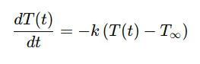These variables help model the cooling process in a precise way, allowing us to predict the temperature of the object at any given time.

**3.0 METHOD OF SOLUTIONS**

To solve the differential equation given by Newton’s Law of Cooling, we apply the **Laplace Transform** technique. Laplace Transforms are particularly effective for solving linear differential equations with initial conditions.

**3.1 Applying Laplace Transform**

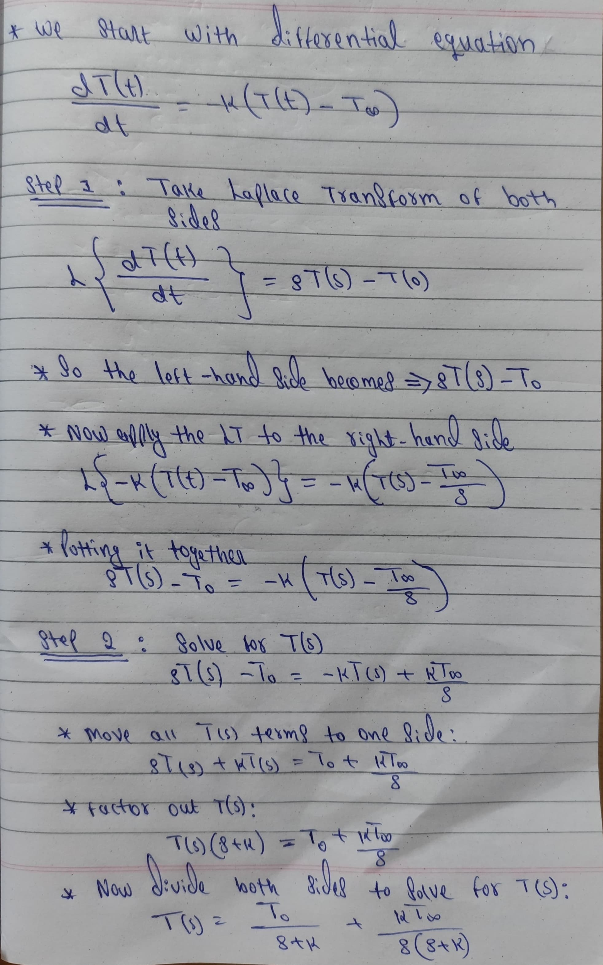

**3.2 Inverse Laplace Transform**

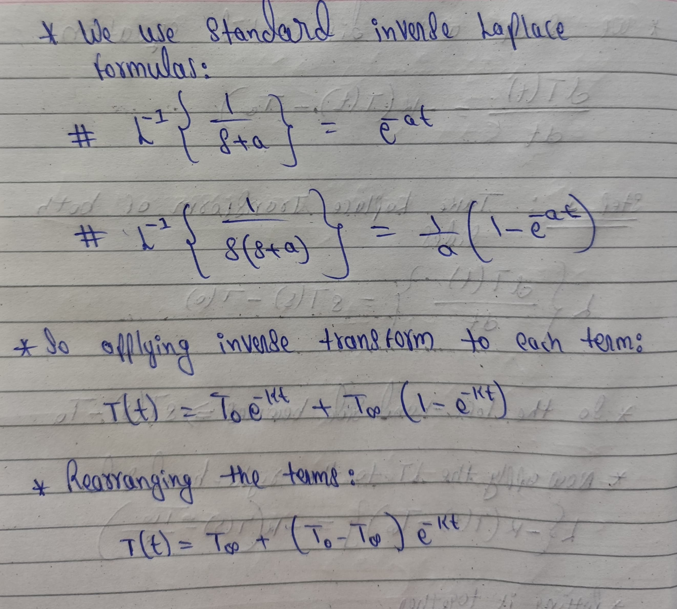Now we apply the **Inverse Laplace Transform** to find T(t) in the time domain.

**This is the final solution**, which describes how the temperature of the object changes over time. It shows that the object’s temperature approaches the surrounding temperature T∞​ as time goes on.

**4.0 RESULT AND DISCUSSION**

**4.1 Qualitative Analysis**

The final solution obtained using Laplace Transform is:

T (t) = T∞ + (T0 − T∞) e−kt

This is an **exponential decay equation**, where the temperature T(t) of the object gradually approaches the surrounding temperature T∞​ over time.

* When t=0 the exponential term is 1:
  + - T (0) = T∞ + (T0−T∞) (1) = T0​
    - This confirms the initial condition is satisfied.
* As t→∞ the exponential term approaches 0:
* T(t)→T∞​
* This shows that the object eventually reaches the ambient temperature

.

**Influence of the Cooling Constant k:**

* A **larger value of k** means faster cooling (the object cools more quickly).
* A **smaller value of k** indicates slower cooling (gradual temperature drop).

This model matches real-world behavior:

* Objects cool rapidly at first when the temperature difference is large.
* As the object’s temperature gets closer to the ambient temperature, the rate of cooling slows down.

**4.2 Graphical Representation**

Below is a general plot showing how the temperature T(t) of an object change over time according to Newton’s Law of Cooling:

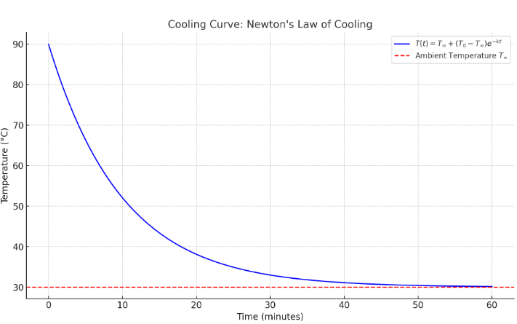

**Parameters Used:**

* Initial Temperature, T0 ​: 90°C
* Ambient Temperature, T∞ ​: 30°C
* Cooling Constant, k: 0.1 per minute
* Time Range: 0 to 60 minutes

**Key Observations:**

* The object cools rapidly at first, then slowly approaches the ambient temperature.
* The curve never crosses the ambient temperature line, only gets closer with time.
* The cooling rate depends on the value of k; a higher k results in faster cooling.

The graph clearly demonstrates the exponential decay nature of cooling, validating the mathematical model.

**5.0 CONCLUSION**

Newton’s Law of Cooling provides a simple yet powerful model to describe how an object’s temperature changes over time when exposed to a cooler environment. By applying the **Laplace Transform**, we converted the differential equation into an algebraic form, solved it efficiently, and derived a general solution:

T (t) = T∞ + (T0−T∞) e−kt

This solution accurately represents the **exponential decay of temperature**, confirming that the object gradually cools down and stabilizes near the ambient temperature. The process is influenced by the **cooling constant (k)**, which determines how quickly the temperature drops.

The mathematical model, supported by graphical analysis, aligns well with real-world observations, making it valuable in various fields such as **forensic science**, **food safety**, and **thermal engineering**.

This project demonstrates how **mathematical tools like Laplace Transforms** can simplify complex physical phenomena and offer practical insights into everyday processes.

**6.0 REFERENCES**

[1] W. E. Boyce and R. C. DiPrima, Elementary Differential Equations and Boundary Value Problems, 11th ed. Hoboken, NJ, USA: Wiley, 2017.

[2] E. Kreyszig, Advanced Engineering Mathematics, 10th ed. Hoboken, NJ, USA: Wiley, 2011.

[3] S. S. Rao, Engineering Mathematics. India: Pearson Education India, 2017.

[4] Massachusetts Institute of Technology, "Differential Equations - Laplace Transform," MIT Open Courseware. [Online]. Available: https://ocw.mit.edu

[5] Khan Academy, "Newton's Law of Cooling," Khan Academy. [Online]. Available: https://www.khanacademy.org